Installing BOOTSTRAP 3

<https://getbootstrap.com/docs/3.4/>

<https://getbootstrap.com/docs/3.4/getting-started/#download>

First create a new project

C:\angular>ng new your-project

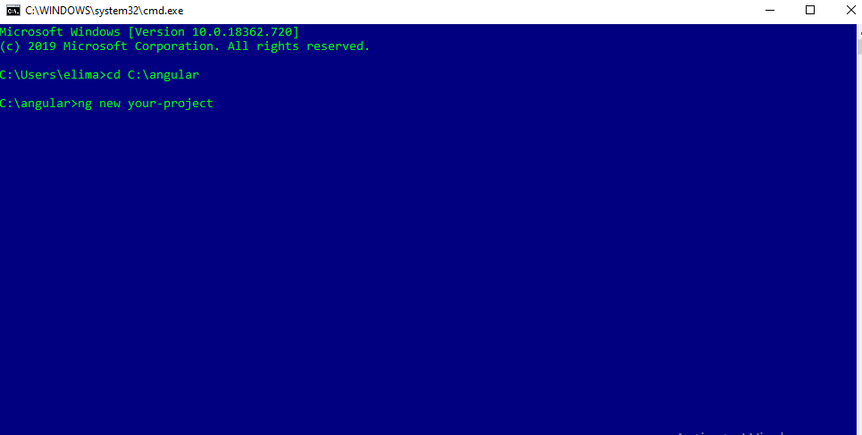

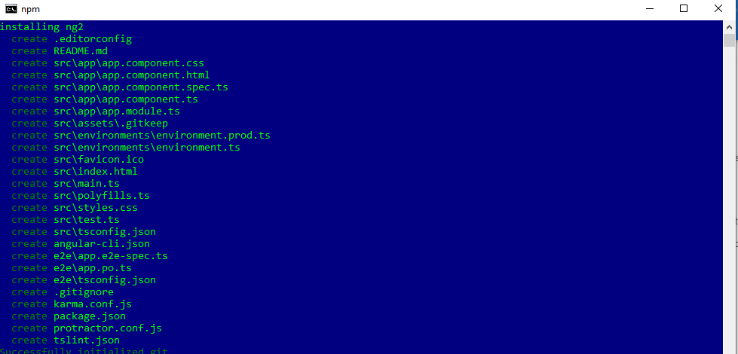

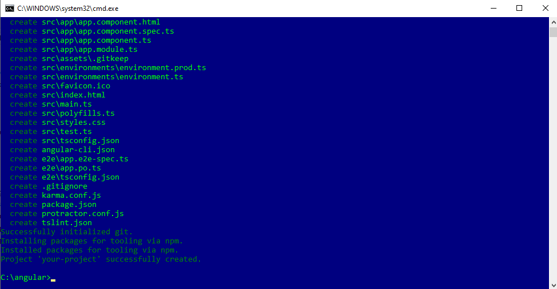

Once created lets open it on VSCODE

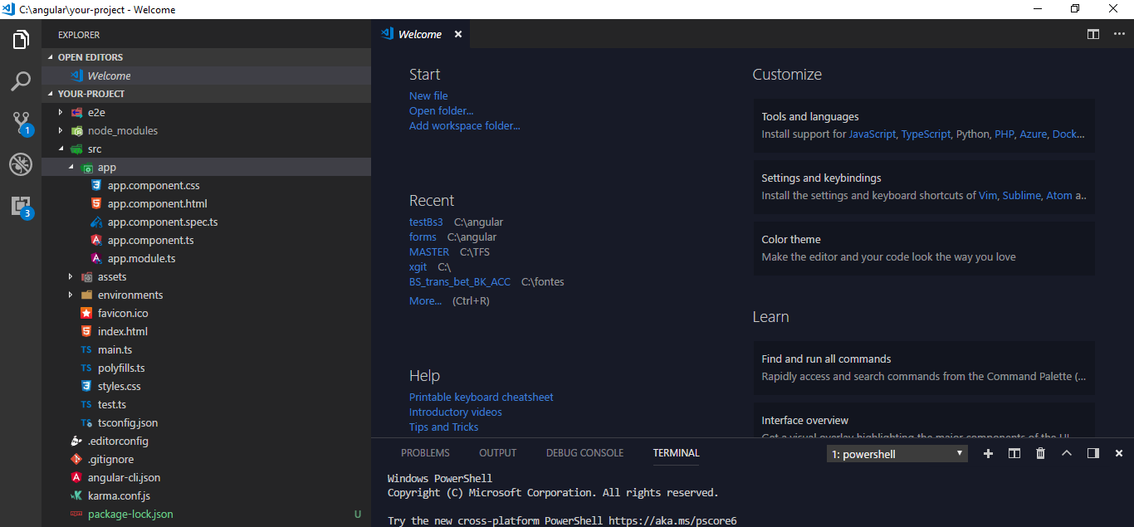

On vs-code lets test our project

Ng serve

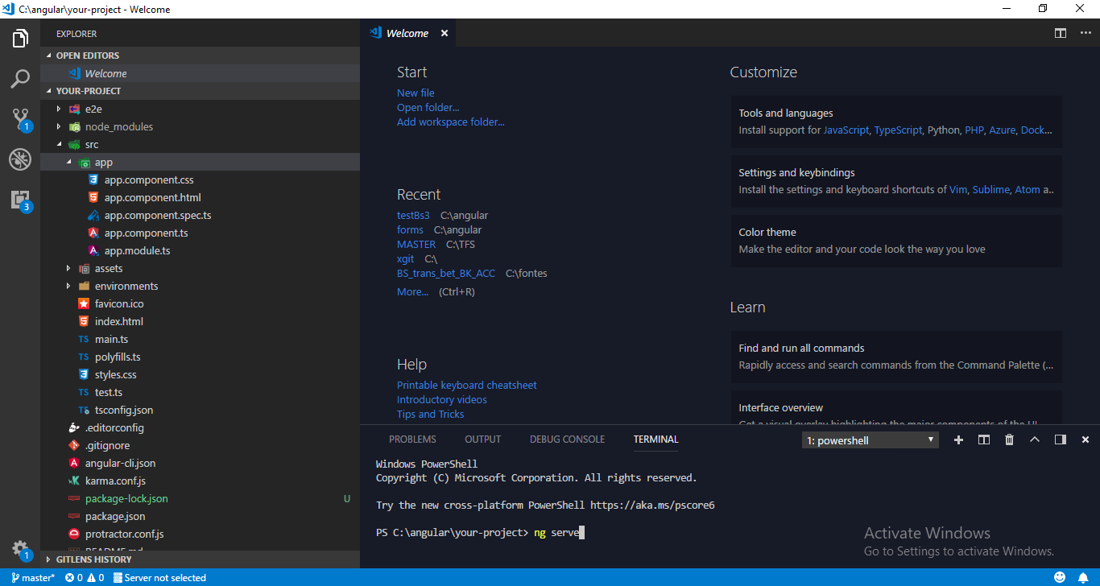

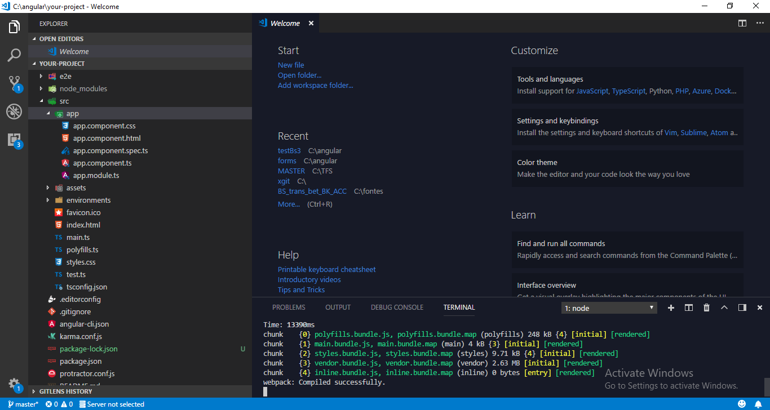

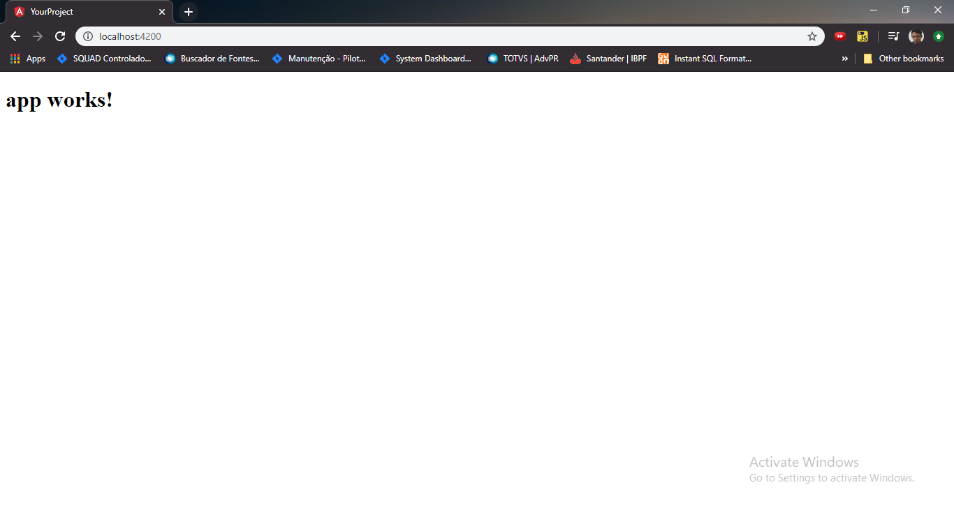

Ok now let’s install bootstrap 3 and bootstrapNGX

npm install ngx-bootstrap bootstrap@3 –save

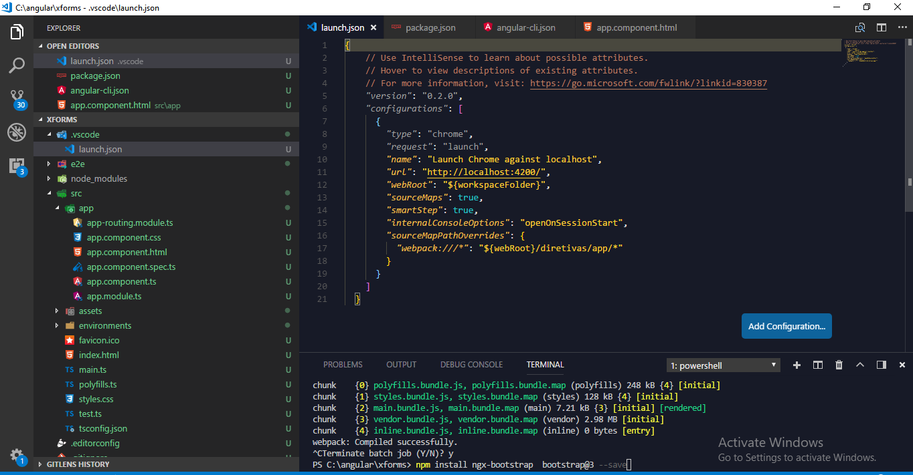

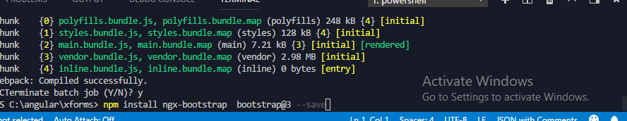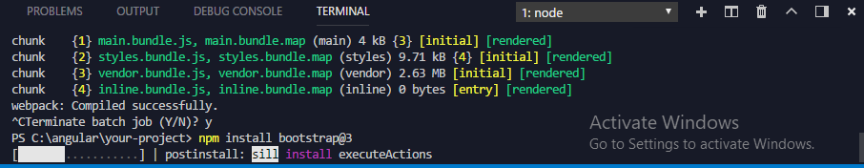

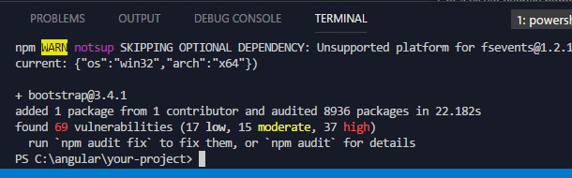

Because we added –SAVE it should already fill automatically the file package.json

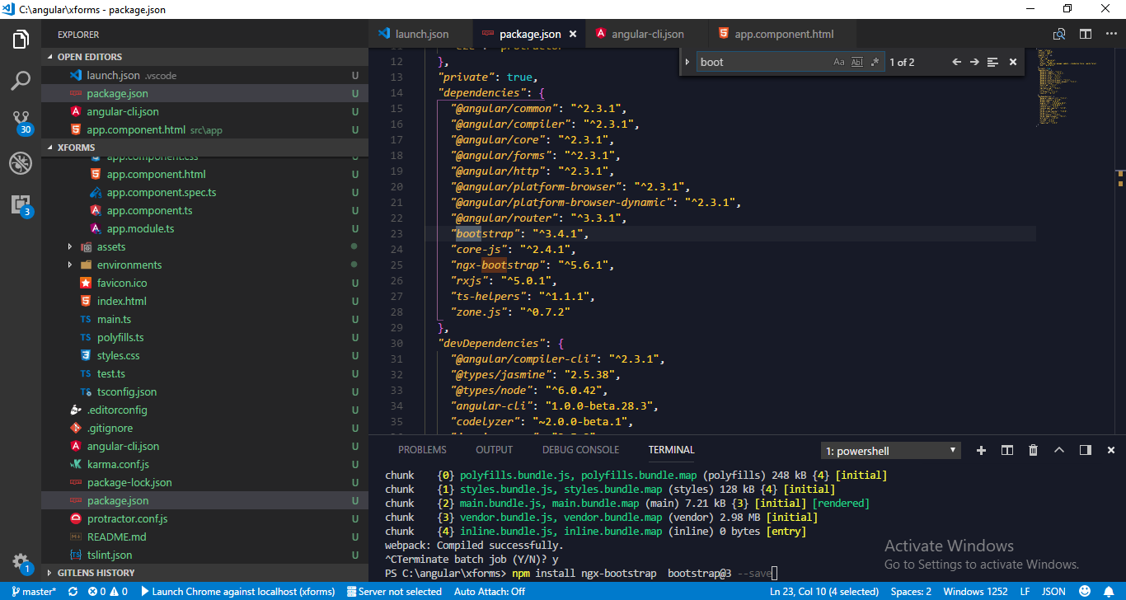

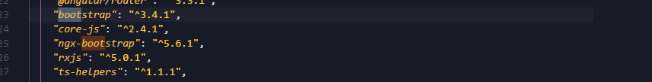

*"bootstrap"*: "^3.4.1",

*"core-js"*: "^2.4.1",

*"ngx-bootstrap"*: "^5.6.1",

Now lets add the CSS of this boot strap on our project.

We must open the file angularcli.json and look for styles

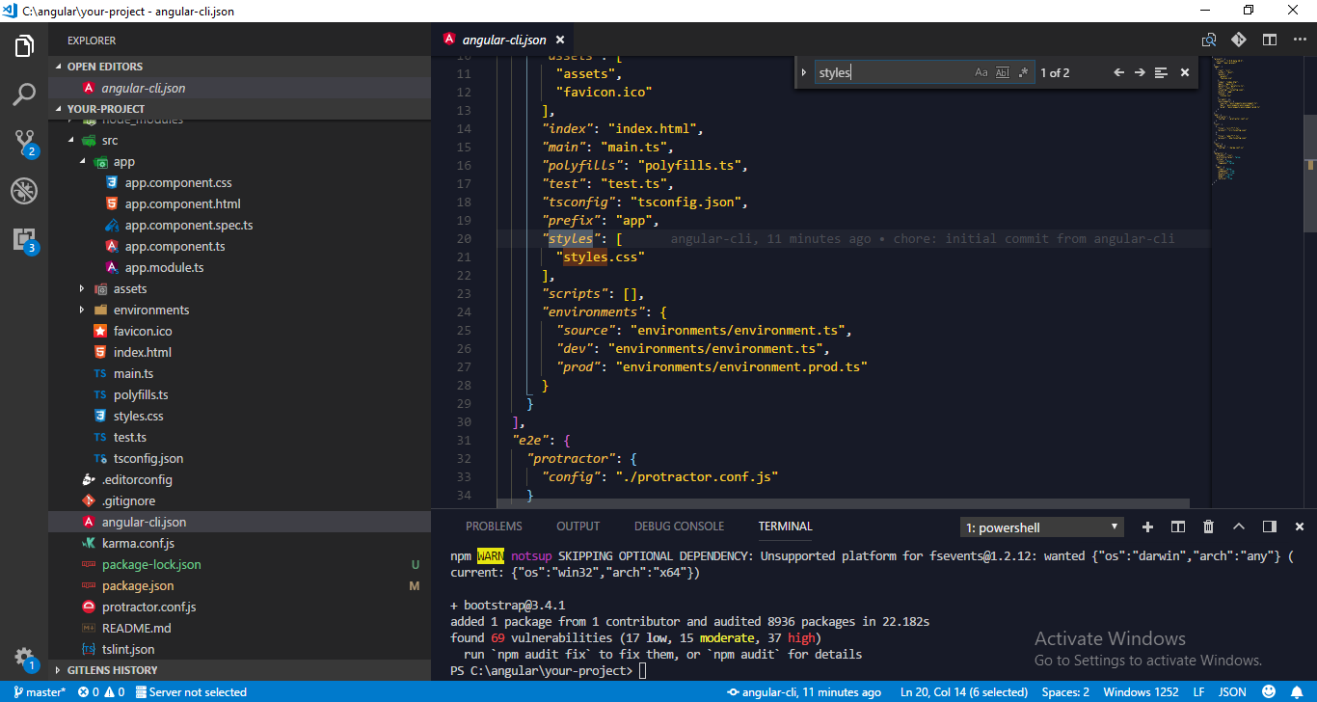

Then bellow

"styles.css"

We should add the path of bootstrap.min.css

"../node_modules/bootstrap/dist/css/bootstrap.min.css"

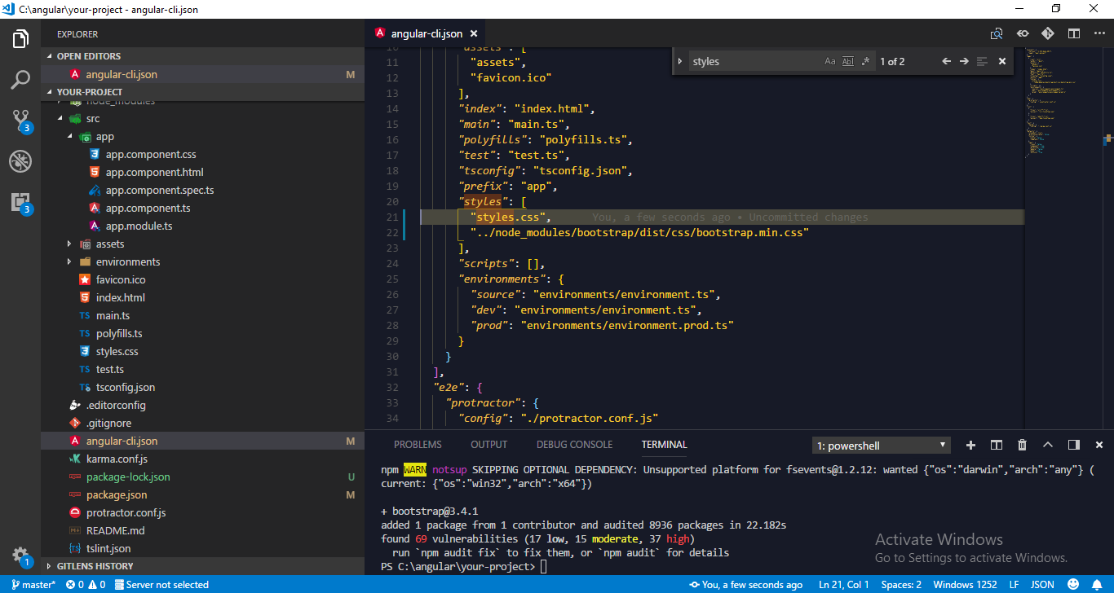

Then to test we should copy the form error in

<https://getbootstrap.com/docs/3.4/css/#forms>

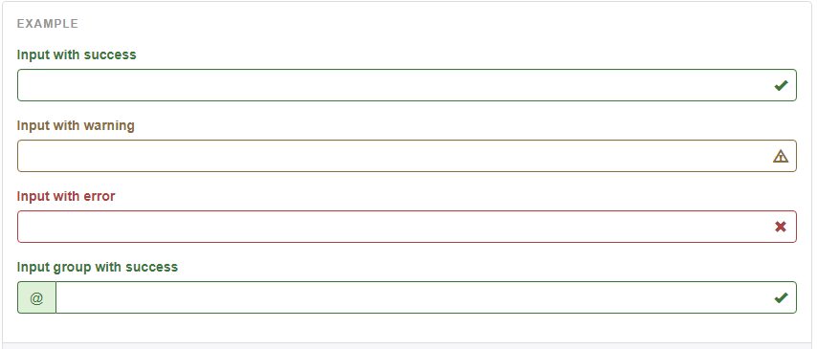

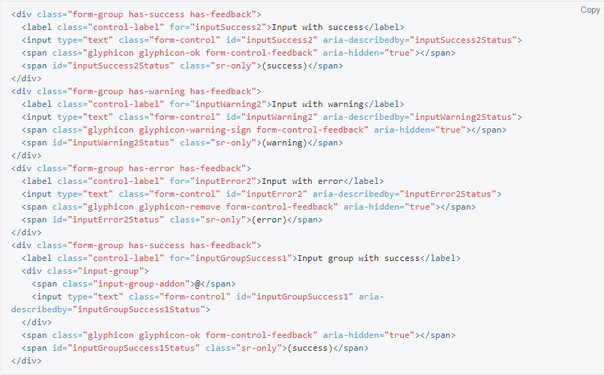

And paste in app.component.html

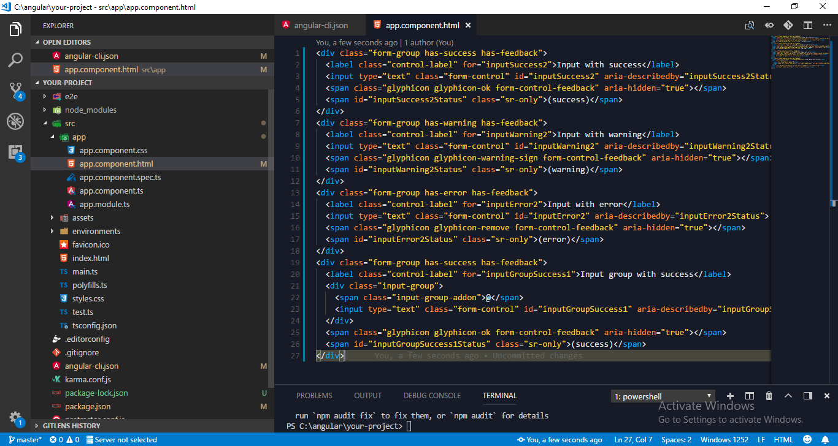

<div class="form-group has-success has-feedback">

<label class="control-label" for="inputSuccess2">Input with success</label>

<input type="text" class="form-control" id="inputSuccess2" aria-describedby="inputSuccess2Status">

<span class="glyphicon glyphicon-ok form-control-feedback" aria-hidden="true"></span>

<span id="inputSuccess2Status" class="sr-only">(success)</span>

</div>

<div class="form-group has-warning has-feedback">

<label class="control-label" for="inputWarning2">Input with warning</label>

<input type="text" class="form-control" id="inputWarning2" aria-describedby="inputWarning2Status">

<span class="glyphicon glyphicon-warning-sign form-control-feedback" aria-hidden="true"></span>

<span id="inputWarning2Status" class="sr-only">(warning)</span>

</div>

<div class="form-group has-error has-feedback">

<label class="control-label" for="inputError2">Input with error</label>

<input type="text" class="form-control" id="inputError2" aria-describedby="inputError2Status">

<span class="glyphicon glyphicon-remove form-control-feedback" aria-hidden="true"></span>

<span id="inputError2Status" class="sr-only">(error)</span>

</div>

<div class="form-group has-success has-feedback">

<label class="control-label" for="inputGroupSuccess1">Input group with success</label>

<div class="input-group">

<span class="input-group-addon">@</span>

<input type="text" class="form-control" id="inputGroupSuccess1" aria-describedby="inputGroupSuccess1Status">

</div>

<span class="glyphicon glyphicon-ok form-control-feedback" aria-hidden="true"></span>

<span id="inputGroupSuccess1Status" class="sr-only">(success)</span>

</div>

And lets test it 